**CRASH ANALYSIS OF A FOUR-WHEEL VEHICLE**

*A Project Report*

*submitted in partial fulfillment of requirements*

*for the award of the degree of*

**Bachelor of Technology**

**In**

**Mechanical Engineering**

**By**

**M. NAGARJUNA REDDY (158A1A0326)**

**U. BRAHMAIAH (158A1A0350)**

**K. REVANTH (158A1A0319)**

**E. ASHOK KUMAR (158A1A0313)**

**A. PHANEENDRA (158A1A0303)**

***Under the esteemed guidance of***

**Mr. D.Ashok, M. Tech., MBA**

**Assistant Professor**



**Department of Mechanical Engineering**

**RISE KRISHNA SAI PRAKASAM GROUP OF INSTITUTIONS**

**(Approved by AICTE, New Delhi, affiliated to JNTUK, Kakinada & certified by ISO 9001:2015)**

**Valluru-523272**

**2015-2019**

**RISE KRISHNA SAI PRAKASAM GROUP OF INSTITUTIONS**

**(Approved by AICTE, New Delhi, affiliated to JNTUK, Kakinada & certified by ISO 9001:2015)**

**Valluru-523272**

**Department of Mechanical Engineering**



***CERTIFICATE***

This is to certify that the project work entitled **“CRASH ANALYSIS OF A FOUR WHEEL VEHICLE”** is a bonafide record of project work done jointly by **M. Nagarjuna Reddy (158A1A0326), U. Brahmaiah (158A1A0350), K. Revanth (158A1A0319), E. Ashok Kumar (158A1A0313) A. Phaneendra (158A1A0303)** under my guidance and supervision and is submitted in partial fulfillment of the requirements for the award of the Degree of Bachelor of Technology in Mechanical Engineering by Jawaharlal Nehru Technological University, Kakinada during the academic year 2018-2019.

PROJECT GUIDE HEAD OF THE DEPARTMENT

**Mr. D.Ashok M. Tech., MBA Dr. J.Krishna, M.E, Ph.D**

**Assistant Professor Professor**

EXTERNAL EXAMINER

**ACKNOWLEDGEMENT**

We would like to express our sincere gratitude to our guide **Mr. D.Ashok** , Assistant Professor, for providing his invaluable guidance, comments, suggestions and support throughout the course of the project.

We express our heart filled thanks to **Dr**.**J.Krishna,** Head of the Department, Mechanical Engineering, for his valuable support to bring out this project in time.

We pay our profound sense of gratitude to our Principal **Prof. Dr. A.V. Bhaskara Rao** for providing an excellent environment in our college and helping us at all points for achieving our task.

We express our sincere thanks to the **Management of RISE Krishna Sai Prakasam Group of Institutions, Valluru** for providing a good environment and infrastructure.

Finally we thank all our faculty members, supporting staff of Mechanical Department and friends for their kind co-operation and valuable help for the completion of the project.

**Project Associates**

**M. NAGARJUNA REDDY (158A1A0326)**

**U. BRAHMAIAH (158A1A0350)**

**K. REVANTH (158A1A0319)**

**E. ASHOK KUMAR (158A1A0313)**

**A. PHANEENDRA (158A1A0303)**

**CONTENTS**

ABSTRACT iii

LIST OF TABLES vi

LIST OF GRAPHS vi

LIST OF BAR GRAPHS vi

**CHAPTER - 1** 1

INTRODUCTION 1

1.1 CRASH TEST 1

*1.1.1 Types of Crash test* 1

1.2 OUTLINE OF THE PROJECT 2

**CHAPTER - 2** 3

LITERATURE REVIEW 3

**CHAPTER - 3** 5

METHODOLOGY 5

**CHAPTER – 4** 6

INTRODUCTION TO CATIA 6

4. INTRODUCTION 6

4.1 DESIGN INTENT 8

4.2 STARTING WITH CATIA 9

*4.2.1 Windows Philosophy* 9

*4.2.2 Catia Documents Concept* 10

*4.2.3 Catia Workbench Concept* 11

4.3 CREATING PROFILES 12

*4.3.1 Design Intent* 12

*4.3.2 Part Design Workbench* 13

*4.3.3 Basic Sketching* 14

*4.3.4 Tools for sketch re-limitation* 16

**CHAPTER – 5** 21

INTRODUCTION TO ANSYS& ANALYSIS 21

5. INTRODUCTION TO ANSYS 21

5.1 GENERIC STEPS TO SOLVING ANY PROBLEM IN ANSYS 21

5.2 SPECIFIC CAPABILITIES OF ANSYS 22

*5.2.1 Structural Analysis* 22

*5.2.2 Thermal Analysis* 23

*5.2.3 Fluid Flow* 24

*5.2.4 Modal Analysis* 24

5.3 INTRODUCTION TO EXPLICIT DYNAMIC ANALYSIS 25

*5.3.1 Explicit Dynamic Analysis Ansys* 26

**CHAPTER - 6** 27

6.1 CAR MODELING IN CATIA 27

6.2 CAR MATERIALS 29

6.3 CRASH ANALYSIS DONE ON A CAR WITH FOLLOWING PARAMETERS AND CONSIDERATIONS 30

*6.2.1 Frontal impact Car crash against an Obstacle(wall)* 30

*6.2.2 Frontal impact Car crash against another Car* 30

*6.2.3 Side impact Car crash against another car* 30

6.3 CAR CRASH ANALYSIS IN ANSYS WORKBENCH 14.5 IN THE MODULE OF ANSYS EXPLICT DYNAMICS 31

**CHAPTER – 7** 44

RESULT TABLES AND GRAPHS 44

**CHAPTER – 8** 50

CONCLUSION 50

REFERENCES 51

**ABSTRACT**

With the improvements in roadways and implementation of new design technologies to automobiles, vehicle safety has found a tremendous turn in these days. Even automobile community is making its continuous effort to improve automobile safety to reduce injury and death drastically. In the present work one such effort is showcased by carrying out crash analysis of car at different velocities using ANSYS Explicit Dynamics approach. Structural Steel Material as wall (obstacle) are used and at the same time Aluminum Alloy and Magnesium Alloys are taken as the body materials for car model. The main purpose of a **crash analysis** is to see how the **car** will behave in frontal or/and sideways collisions.

Car modeling is done in CATIA and Analysis is done in ANSYS WORKBENCH 14.5, Especially in the module of ANSYS EXPLICIT DYNAMICS 14.5.

**LIST OF FIGURES**

Figure 1 : Model with Features 6

Figure 2 : Parametric Feature 7

Figure 3 : Solid Modeling 8

Figure 4: Toolbars 10

Figure 5 : Mouse picks 10

Figure 6 : CATIA V5 documents 11

Figure 7 : Workbenches 12

Figure 8 : Support Plate 12

Figure 9 : Workbench (Part Design) 13

Figure 10 : Reference Planes 13

Figure 11 : Sketch 14

Figure 12 : Sketch Plane (Non positioned sketch) 14

Figure 13 : Profile toolbar 15

Figure 14 : Operation toolbar 15

Figure 15 : Constraint toolbar 16

Figure 16 : Sketcher re-limitation tools 16

Figure 17 : feature of Base 17

Figure 18 : Pocket feature 18

Figure 19 : Profile sketches 18

Figure 20 : Open profiles 19

Figure 21 : Multi-pad 19

Figure 22 : Multi-pocket 20

Figure 23 : Axis Revolve 20

Figure 25 : Car sketch in Catia 27

Figure 26 : final car model in 3D 27

Figure 27 : Car Vs. Car frontal impact 28

Figure 28 : Car Vs. Car Side impact 28

Figure 29 : Explicit dynamics Environment 31

Figure 30 : Meshed Model car vs. obstacle 32

Figure 31 : Meshed Model car vs. car frontal impact crash 33

Figure 32 : Meshed Model car vs. car side impact crash 33

Figure 33 : 45+AL+AL+F+DEFORAMTION 34

Figure 34 : 45+AL+AL+F+STRESS 34

Figure 35 : 45+AL+SS+F+DEFORMATION 35

Figure 36 : 45+AL+SS+F+STRESS 35

Figure 37 : 45+MG+MG+F+DEFORMATION 36

Figure 38 : 45+MG+MG+F+STRESS 36

Figure 39 : 45+MG+SS+F+DEFORMATION 37

Figure 40 : 45+MG+SS+F+STRESS 37

Figure 41 : 55+AL+SS+F+DEFORMATION 38

Figure 42: 55+AL+SS+F+STRESS 38

Figure 43 : 55+MG+SS+F+DEFORMATION 39

Figure 44 : 55+MG+SS+F+STRESS 39

Figure 45 : 55+AL+AL+S+DEFORMATION 40

Figure 46 : 55+AL+AL+S+STRESS 40

Figure 47 : 55+MG+MG+S+DEFORMATION 41

Figure 48 : 55+MG+MG+S+STRESS 41

Figure 49 : 60+AL+AL+S+DEFORMATION 42

Figure 50 : 60+AL+AL+S+STRESS 42

Figure 51 : 60+MG+MG+S+DEFORMATION 43

Figure 52 : 60+MG+MG+S+STRESS 43

# **LIST OF TABLES**

Table 1 : Car Frontal Impact with Obstacle (Car Material as Al Alloy) 43

Table 2 : Car Frontal Impact with Obstacle (Car Material as Mg Alloy) 43

Table 3 : Car Frontal Impact with Car 43

Table 4 : Car Side Impact with Car (Car Material as Al Alloy) 44

Table 5: Car Side Impact with Car (Car Material as Mg Alloy) 44

# **LIST OF GRAPHS**

Graph 1 : Total Deformation with respect to different velocities (Car Vs. Obstacle) 44

Graph 2 : Strain with respect to different velocities (Car Vs. Obstacle) 45

Graph 3 : Stress with respect to different velocities (Car Vs. Obstacle) 45

Graph 4 : Total Deformation with respect to different velocities (Car Vs. Car) 47

Graph 5 : Strain with respect to different velocities (Car Vs. Car) 48

Graph 6 : Stress with respect to different velocities (Car Vs. Car) 48

# **LIST OF BAR GRAPHS**

Bar Graph 1 : Total Deformation with respect to materials(Car Vs. Car) 46

Bar Graph 2 : Stress with respect to materials(Car Vs. Car) 46

Bar Graph 3 : Strain with respect to materials(Car Vs. Car) 47

# **CHAPTER - 1**

# **INTRODUCTION**

With increase in fuel price and need for safer vehicle, it is important to analyse the crashworthiness of automobile structure. Crashworthiness can be defined as the capability of a structure to safeguard its passengers during an impact. Based on the nature of impact and the type automobile involved in the crash, different parameters are used to determine the crashworthiness of the structure. Crashworthiness can be analysed either computationally, i.e. using computer tools such as ANSYS EXPLICIT DYNAMICS MODULE IN ANSYS WORKBENCH, MADYMO, PAM-CRASH, MSC Dytron, LS-DYNA or by experimental method.

## **1.1 CRASH TEST**

In order to assure safety for different modes of transports or its related components and systems, proper design standards are maintained and destructive tests are performed to check for crashworthiness. This procedure of testing the automobiles and their component by destructive method is known as crash test. proper design standards are maintained and destructive tests are performed to check for crashworthiness. This procedure of testing the automobiles and their component by destructive method is known as crash test.

### ***1.1.1 Types of Crash test***

**A**. **Frontal Impact Tests**: This is the most common type of crash test. In this method vehicles are made to hit solid wall, usually made up of concrete, at different speeds. This type of crash test can also be carried out between two vehicles colliding each other.

**B**. **Side Impact Tests:** In this type of test a stationary test vehicle is fixed on the driver side and high velocity moving barrier which is deformable is made to hit the test vehicle at 90-degree angle on the driver side.

## **1.2 OUTLINE OF THE PROJECT**

The present work crash analysis on a car (four wheel vehicle),with mainy two special cases , **Case 1.** Taking different velocities of a car

**Case 2**. Taking car body materials are alloys (Aluminium Alloy and Magnesium Alloy).

In the first chapter, introduction about Crash test necessity of crash test and its main types are discussed.

In the second chapter , detailed review of the previous crash test analysis are discussed.

In the third chapter is Methodology is discussed about how we are taken car model.

In the fourth and fifth chapters Introduction to Catia and crating models, taking constraints and some more entities are discussed.

In the sixth chapter car modeling in Catia and velocity considerations, materials of car are discussed as well as Analysis is done on a car in ANSYS EXPLICIT DYNAMICS 14.5 are discussed.

In the seventh chapter results and comparative graphs are discussed with respect to velocity considerations and material considerations.

In the eight chapter consists of conclusion and references of the present work.

# **CHAPTER - 2**

# **LITERATURE REVIEW**

[1] Thacker et. Al performed crash-checking out study on Honda accord in 1997 for simulation by taking car after which, automobile turned into pieces all the way by primary elements, element become check, categorized, fabric find out.

[2] Anderson al. has discussed that to growth crash performance in automotive cars it's far necessary to apply new strategies inclusive of use of energy absorber and materials. Components connected to crash safety ought to transmit or take in energy. The power absorbing functionality of a specific element is an aggregate of geometry and fabric residences.

[3] Evans D and Morgan T have studied that as car producers keep emerging as extra competitive with the styling of new cars, bumper system technologies could be required to locate new solutions that match into the reduced package deal spaces at the same time as persevering with to meet the car overall performance and price requirements. It changed into advised to introduce new and innovative Expanded Polypropylene (EPP) foam technology and strategies.

[4] Bautista et al. look into unique effect in which precise cloth by optimizing the beam form through simulation. Brief studies about car body, car body materials, and light weight composites materials, and impact mechanism is done in this project. By using 3d modeling software solid works 2016 hatch back body of car is modeled and imported to ANSYS Workbench software for crash analysis. Explicit Dynamics module is used from ANSYS software, for study of car crash on different speeds. Three different speeds of car, 50km/hr., 100 km/hr., and 150 km/hr. are selected for crash investigation. Four different light weight high strength materials are selected as the material of car body such as Aluminium alloy, Aluminium metal matrix (KS1275), High strength carbon fiber & Kevlar -49. Analysis is performed on four different speeds on three different speed conditions. Stress, strain deformation due to crash on front surface area of car body due to crash with concrete wall will analyze for suitable material will provide high s/w and can provide the maximum safety to passengers due to crash.

[5] Kihlberg and Tharp (1968) investigated the relation- ship between motor vehicle crashes and highway design elements using data from five states by analyzing crash counts on homogenous road segments of two- and multi- lane roadways. They found that number of lanes and median affect crash rates. The effect of the median, however, was not very marked and was found in only some of the states examined.

[6] Cleveland, Kostyniuk, and Ting (1984, 1985) examined crash data for two-lane rural highway segments from 14 states by using statistical categorical techniques. They confirmed Versace’s observation that good (or bad) geometric features were usually found together, and grouped cross-sectional features (lane width, shoulder width, side slope, ditch condition) that were usually found together in roads into a set of “geo- metric bundles” that varied from excellent to poor. An effect of the geometric bundles on crashes was found, but it was not as important as the effects of traffic volume and access density and the interactive effect of the geometric bundles and access density.

[7] (1960), in analyzing Schoppert's data, recognized that roadway features were correlated with each other; that is, good cross- sectional elements usually go together, and furthermore, good cross-sectional elements were usually found together with good alignment. These, he noted, are the result of road design and construction practices. Versace identified shoulder and lane widths as factors affecting crash occurrence but noted that their effects were not as important as that of traffic vol- use. Increased crash rates with decreased lane and shoulder widths were also reported by Dart and Mann (1970) and Roy Jorgensen and Associates, Inc. (1978).

# **CHAPTER - 3**

# **METHODOLOGY**

Method of Analysis Crash-testing requires some of the look at automobile to be pulverized at some stage in the exams furthermore, is also tedious and uneconomical. One new late sample this is increasing huge incidence is PC recreated crash-trying out. The model in finite element, let us consider, the car as model which is used for simulation before going to actual vehicle test will give genuine performance.

Explicit Dynamics Analysis For many engineering applications ANSYS Explicit dynamics simulations in physical occasions to test in easy.

Explicit Dynamics Analysis ANSYS

Explicit Dynamics engineering simulation solutions square measure good for simulating physical occasions that occur during a pace and will give birth to cloth damage or failure. These types of events square measure frequently exhausting or luxurious to appear at through an experiment. Simulation offers insight and an in-depth info of the essential physics taking space and offers engineers a danger to form vital modifications before their merchandise square measure placed into service, while mistakes in style could also be overpriced.

# **CHAPTER – 4**

# **INTRODUCTION TO CATIA**

## **4. INTRODUCTION**

In thesis, CATIA is to model the centrifugal blower. Complex and rich design can be created by CATIA, a robust application. It is *feature based* mechanical design software, a *parametric solid modeling* design tool. It uses windows graphical user interface and easy to learn. Without or with *constraints*, *fully associative* 3D solid models can be created with the help of CATIA. In the mean time we can use user defined or automatic relations for capturing the design intent.

#### Feature-based

Document of CATIA is made from individual elements similar to an assembly which is made from a number of individual parts. The elements of CATIA are called features. During document creation, a number of features such as charts, fillets, chamfers, holes, pockets and pads can be added. These created features may be applied to the work piece directly.

Classification of features can be dress-up or sketch-based:

* We can directly create dress-up features on the solid model. This type of feature’s examples is chamfers and fillets.
* 2D sketch is used to create sketch-based features. In general, transformation of sketch is done into a 3D solid by lofting, sweeping, rotating or extruding.

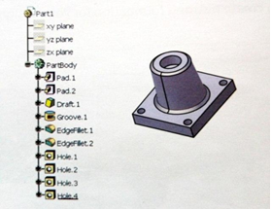

**Figure 1 : Model with Features**

#### Parametric

The model stores the relations and dimensions used for creating a feature. With the help of these parameters, we can make changes in the model as well as any changes to the model can be done easily.

* Relations:Information such as connectivity, tendency and parallelism are included in this parameter. With the help of feature control symbols, information of such type is exported in the drawings. After this information is captured in the sketch, in the initial stage itself, we can fully capture our design intent.
* Driving dimensions:We can create features with the help of this parameter. Dimensions associating itself in the feature as well as sketched geometry dimensions are included in this feature. In initial stage itself, we can fully capture our design intent once information is captured in the sketch A cylinder pad can be used as an example. Sketched circle diameter controls the pad diameter and the depth extruded in the circle controls the pad's height.

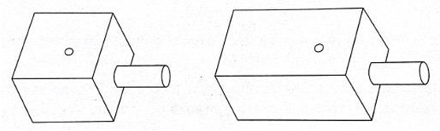

**Figure 2 : Parametric Feature**

#### Solid Modeling

CAD system uses solid model supposed to be the best complete geometric model. All the surface geometry and wireframe are contained in it which are required to describe fully the model's faces and edges. Apart from geometric information, topology of solid models are also conveyed by them. Geometry together are also related by solid modeling. As an example, identification of faces (surfaces) at edges (curves) may be included in topology. Adding new features becomes easier by using this intelligence. Example - if a model requires a fillet, simply an edge can be selected and a radius can be specified to create it

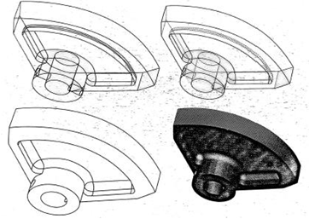

**Figure 3 : Solid Modeling**

#### Fully Associative

Model of a CATIA is completely associative with drawings and assemblies or parts referencing it. There is automatic reflection of any changes made in the model to the drawings, assemblies or/and parts. Similarly, any change done to the assembly or drawing is reflected back in model.

#### Constraints

Relationships among a model's features are established by geometric constraints (for example coincident, vertical, geometric, horizontal and parallel) by fixation of their position with respect to each other. Additionally, for establishing mathematical relationships among parameters, equations may be used. With the help of equations and constraints, it may be guaranteed that design concepts like equal radii and through holes are captured & maintained.

## **4.1 DESIGN INTENT**

Planning how to construct a part’s solid model is termed as design intent. it is done in order to convey properly the solid model's functional and visual aspects. Before and during part's modeling, design intent is considered. It is done in order to use CATIA like parametric modeler efficiently. Model creating technique shall affect the behavior of model whenever a change is there in future.

Many aspects are affected by the manner of building a solid model. It may include: requirements of resources for computing a new result, stability at the time of process change and its flexibility to change. Thus, the design intent should be considered for the creation of an efficient solid model. This is an important step.

Capturing of design intent is contributed by the following factors:

* Dimensioning:The design intent is impacted by the manner of dimensioning a sketch. Dimensions must be added in such a way which shows how changes can be done by us in order to control the elements.
* Equations:Dimensions are related mathematically by equations. For forcing changes, equations provide an external method.
* Automatic (Implicit) Relations:Common geometric relationships are provided by automatic relations among objects like vertical, horizontal, perpendicular and parallel. This is based on the manner of geometry sketching.
* Additional Relations:These are the relations which provide another method for connecting related geometry. Offset, coincident and concentric are some of the common relations.

## **4.2 STARTING WITH CATIA**

### ***4.2.1 Windows Philosophy***

Behavior of CATIA on windows operating system is similar to other windows applications. Entire CATIA commands can be accessed through traditional menus. There are additional related options to some menu options. Frequently used commands which are contained in toolbars can be accessed quickly. Workbenches organize toolbars. According to our preferences these icons can be relocated, rearranged and customized. For example, undo, cut, print, save, open and access online documentation,

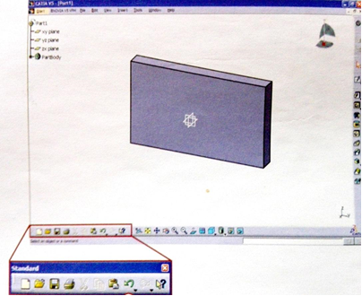

**Figure 4: Toolbars**

To select and indicate user input, three-button mouse is used in CATIA.

* A. For selecting items or elements displayed on screen, we use left mouse button.
* B. For pointing and indicating to a direction on screen, we use center mouse or thumb wheel.
* C. On the screen, a contextual menu required to preselect or select elements on screen is displayed using right mouse button.

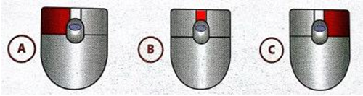

**Figure 5 : Mouse picks**

### ***4.2.2 CATIA DOCUMENTS CONCEPT***

Different types of CATIA documents can be created, modified & saved. Geometrical specifications and information defining an object are contained in these documents. Documents which are most common are:

* A. A part document (CAT part)
* B. An assembly document (CAT Product)
* C. A drawing document (CAT Drawing)

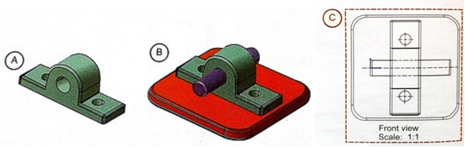

**Figure 6 : CATIA V5 documents**

### ***4.2.3 CATIA Workbench concept***

For working on CATIA document, one of the work benches assigned to it must be used by us. A set of tools dedicated for performing specific tasks is contained by each work bench.

Most commonly used workbenches are listed below:

Part Design:It is used to design parts with the help of solid modeling approach.

Sketcher:It is used to create 2D profiles with associated constraints. This 2D profile can then be used for creating 3D geometry.

Wireframe and Surfaces:It is used to create features of complex part with surface elements and 3D wireframe.

Assembly Design:In an assembly context, it is used for creating specifications, features and constraints for parts.

Generative & Interactive Drafting:It is used to create drawings from assembly and its parts.

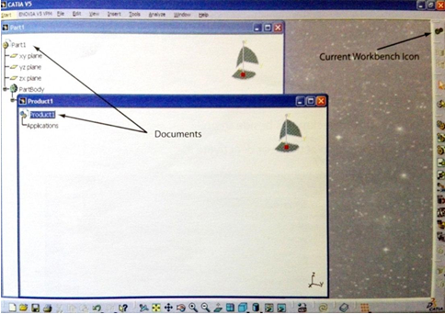

**Figure 7 : Workbenches**

## **4.3 CREATING PROFILES**

### ***4.3.1 Design Intent***

Whenever a part is created, a profile is need to be created which incorporates part's design intent. Planning of method of constructing a part's solid model is the design intent. This is done for conveying suitably the solid model's functional and visual aspects. A support plate given in the following figure is taken as an example for explaining the design intent. Support plate is Drill Support subassembly's part.

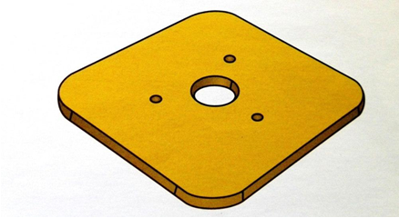

**Figure 8 : Support Plate**

### ***4.3.2 Part Design Workbench***

3 default reference planes alone are contained in a new plane. In specification tree, these planes are fist elements always. These reference planes are the foundation of feature creation. To create profiles, a suitable sketch support needs to be selected.

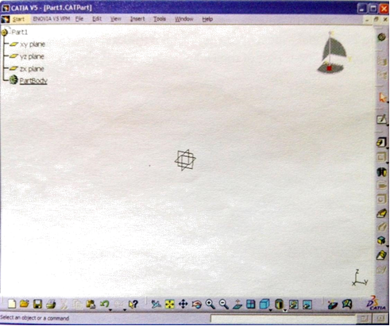

**Figure 9 : Workbench (Part Design)**

#### Reference Plane

In any part profile, first three features are default reference planes. Derivation of their names comes from the plane to which they are parallel, i.e., XY, YZ & ZX planes.

A support on which creation of first sketch takes place is provided by the reference plane.

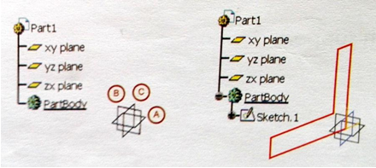

**Figure 10 : Reference Planes**

#### Concept of Sketch

2D profile is the starting point of each part which is new. Use of Two-Dimensional sketcher workbench which is a workspace, generation of this profile may take place. Elements created inside sketcher are 2-Dimensional WIREFRAME exclusively.

Geometry generated in sketcher is a single sketch in part design workbench. Inside part design workbench, 3D feature is created with the help of current sketch. For sketches' fast alteration, they are constrained by simple alteration of dimensions.

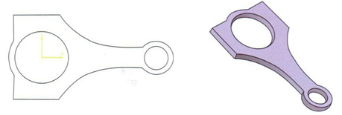

**Figure 11 : Sketch**

### ***4.3.3 Basic Sketching***

One creates sketch profile within sketcher workbench, If specification of origin & orientation is not in a sketch then such a sketch is termed as non-positioned sketch. Sketcher icon is selected first for creating a non-positioned sketch. After that in geometry area or specification tree, reference plane is selected. Animation is performed in geometry area and after that alignment of selected plane parallel to screen takes place. Now in selected plane, construction of profiles will be done.

Within sketcher workbench, creation of positioned sketches takes place.

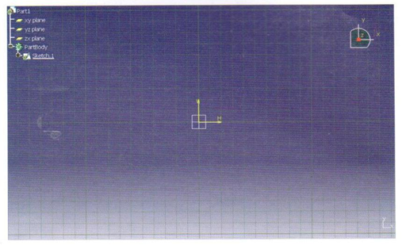

**Figure 12 : Sketch Plane (Non positioned sketch)**

Following functions are available by Profile Toolbar tools for creating sketched geometry:

1. Profiles defined by users
2. Profiles which are predefined
3. For creating Circles
4. For creating Splines
5. For creating Parabolas and Ellipses
6. For creating Lines
7. For creating Axes
8. For creating Points.

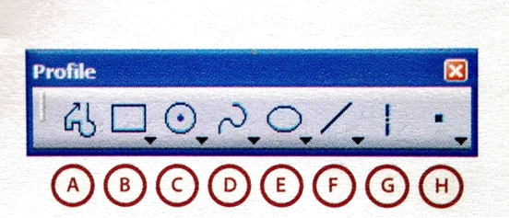

**Figure 13 : Profile toolbar**

The existing constructed geometry can be changed using **Operation** toolbar.

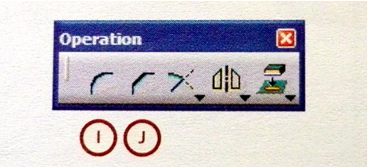

**Figure 14 : Operation toolbar**

**Geometrical Constraints:** Sketched elements’ Positioning are specified by these constraints. Setting of these constraints can be achieved with the help of constraint toolbar icons

Constraint elaborated in the dialog box

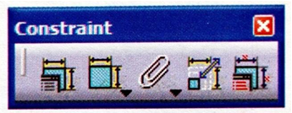

**Figure 15 : Constraint toolbar**

### ***4.3.4 Tools for sketch re-limitation***

Sketched geometry which exists at present can be extended or trimmed with the help of re-limitation tools. **Operation** toolbar contains fly out menu called *re-limitation* toolbar where re-limitation tools can be found. Following tools are included in re-limitation toolbar:

1. Trim
2. Break
3. Quick Trim
4. Close
5. Complementary angle

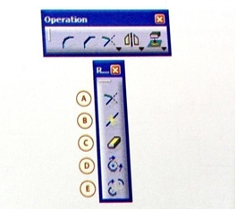

**Figure 16 : Sketcher re-limitation tools**

Beginning of any part design should be with a strong **base feature**. Foundation or primary shape of any part design is represented by this base feature. Other geometries may be removed or added taking into account this feature. The basis form of the base feature is a surface element or a sketch.

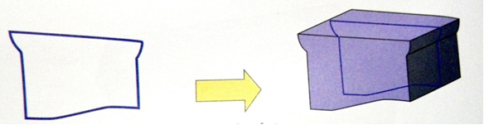

**Figure 17 : feature of Base**

Basic element selection of base feature should be such that it should convey the part’s function or the primary shape of the part. It is not meant to completely define each and every detail of the base feature. For example, pockets, holes fillets or other features should be created as base feature sketch part. The creation of this can be done at a later stage as separate features.

For completing the design, material **adding or removing feature** is needed to be defined after selection of base feature.

Material adding features are listed below:

* Pad
* Shaft
* Rib
* Stiffener
* Multi-sections solid

Material removing features are listed below:

* Hole
* Slot Groove
* Pocket
* Removed Multi-section solids

**Pads** are created for adding materials to a model.

**Pockets** are created for removing materials from a model.

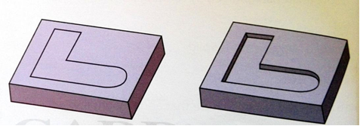

**Figure 18 : Pocket feature**

Dimensions define the pad’s length or pocket’s length. If a limiting element defines a pocket or a pad then it is associated to that element. Different options of types of depth are listed below:

1. Dimension
2. Up to Next
3. Up to Last
4. Up to Plane
5. Up to Surface

There are restrictions on profile sketches of **pocket/pad**. Generally connecting entities forming closed loop should be part of profile sketch. Only Thick option should be used with open-loop profile sketches.

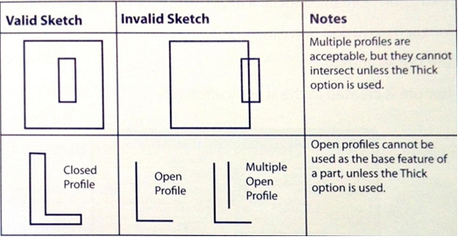

**Figure 19 : Profile sketches**

Groove features or pads and pockets features can be created by using **open profiles.** For limiting new feature of an existing geometry, open profile feature can be considered. Need of creating and constraining additional sketched geometry is eliminated if existing geometry is used to re-limit a feature. Stability of re-limiting feature should always be ensured. Profile may fail if re-limiting feature is heavily modified or removed.

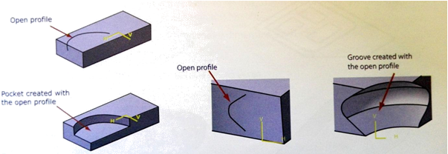

**Figure 20 : Open profiles**

Numerous pockets/pads can be created with the help of pockets and pads features. Between these tools it requires at least two non-intersecting closed profiles. We can create multiple features much faster by using these tools.

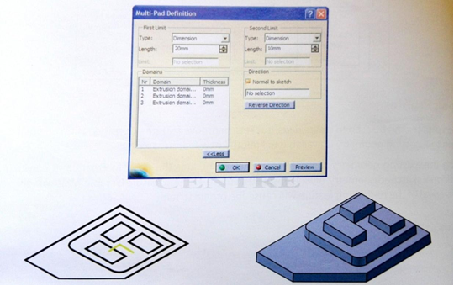

**Figure 21 : Multi-pad**

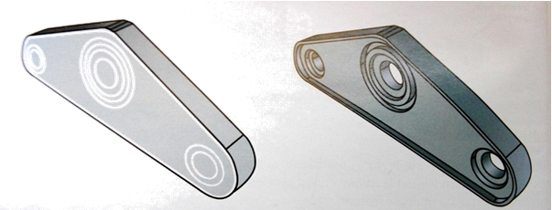

**Figure 22 : Multi-pocket**

Revolved features like grooves and shafts can be created by using an **axis** as a reference. About this axis sketched profile is revolved. Use of axis is also possible to generate symmetrical sketched elements within sketched workbench.

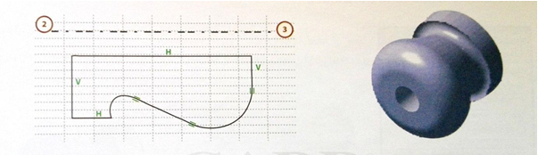

**Figure 23 : Axis Revolve**

# **CHAPTER – 5**

# **INTRODUCTION TO ANSYS& ANALYSIS**

## **5. INTRODUCTION TO ANSYS**

ANSYS is general-purpose finite element analysis (FEA) software package.  Finite Element Analysis is a numerical method of deconstructing a complex system into very small pieces (of user-designated size) called elements. The software implements equations that govern the behaviour of these elements and solves them all; creating a comprehensive explanation of how the system acts as a whole. These results then can be presented in tabulated or graphical forms.  This type of analysis is typically used for the design and optimization of a system far too complex to analyses by hand.  Systems that may fit into this category are too complex due to their geometry, scale, or governing equations.

ANSYS is the standard FEA teaching tool within the Mechanical Engineering Department at many colleges. ANSYS is also used in Civil and Electrical Engineering, as well as the Physics and Chemistry departments.

ANSYS provides a cost-effective way to explore the performance of products or processes in a virtual environment. This type of product development is termed virtual prototyping.

With virtual prototyping techniques, users can iterate various scenarios to optimize the product long before the manufacturing is started. This enables a reduction in the level of risk, and in the cost of ineffective designs. The multifaceted nature of ANSYS also provides a means to ensure that users are able to see the effect of a design on the whole behavior of the product, be it electromagnetic, thermal, mechanical etc.

## **5.1 Generic Steps to Solving any Problem in ANSYS**

Like solving any problem analytically, you need to define (1) your solution domain, (2) the physical model, (3) boundary conditions and (4) the physical properties. You then solve the problem and present the results. In numerical methods, the main difference is an extra step called mesh generation. This is the step that divides the complex model into small elements that become solvable in an otherwise too complex situation. Below describes the processes in terminology slightly more attune to the software.

#### Build Geometry

Construct a two- or three-dimensional representation of the object to be modeled and tested using the work plane co-ordinate system within ANSYS.

#### Define Material Properties

Now that the part exists, define a library of the necessary materials that compose the object (or project) being modeled.  This includes thermal and mechanical properties.

#### Generate Mesh

At this point ANSYS understands the makeup of the part.  Now define how the modeled system should be broken down into finite pieces.

#### Apply Loads

Once the system is fully designed, the last task is to burden the system with constraints, such as physical loadings or boundary conditions.

#### Obtain Solution

This is actually a step, because ANSYS needs to understand within what state (steady state, transient… etc.) the problem must be solved.

#### Present the Results

After the solution has been obtained, there are many ways to present ANSYS’ results, choose from many options such as tables, graphs, and contour plots.

## **5.2 SPECIFIC CAPABILITIES OF ANSYS**

### ***5.2.1 Structural Analysis***

Structural analysis is probably the most common application of the finite element method as it implies bridges and buildings, naval, aeronautical, and mechanical structures such as ship hulls, aircraft bodies, and machine housings, as well as mechanical components such as pistons, machine parts, and tools.

Static Analysis - Used to determine displacements, stresses, etc. under static loading conditions. ANSYS can compute both linear and nonlinear static analyses. Nonlinearities can include plasticity, stress stiffening, large deflection, large strain, hyper elasticity, contact surfaces, and creep. Transient Dynamic Analysis - Used to determine the response of a structure to arbitrarily time-varying loads.

All nonlinearities mentioned under Static Analysis above are allowed. Buckling Analysis - Used to calculate the buckling loads and determine the buckling mode shape. Both linear (eigen-value) buckling and nonlinear buckling analyses are possible.

In addition to the above analysis types, several special-purpose features are available such as **Fracture mechanics**, **Composite material analysis**, **Fatigue**, and both **p-Method and Beam analyses.**

### ***5.2.2 Thermal Analysis***

ANSYS is capable of both steady state and transient analysis of any solid with thermal boundary conditions. Steady-state thermal analyses calculate the effects of steady thermal loads on a system or component. Users often perform a steady-state analysis before doing a transient thermal analysis, to help establish initial conditions. A steady-state analysis also can be the last step of a transient thermal analysis; performed after all transient effects have diminished. ANSYS can be used to determine temperatures, thermal gradients, heat flow rates, and heat fluxes in an object that are caused by thermal loads that do not vary over time. Such loads include the following:

* Convection
* Radiation
* Heat flow rates
* Heat fluxes (heat flow per unit area)
* Heat generation rates (heat flow per unit volume)
* Constant temperature boundaries

A steady-state thermal analysis may be either linear, with constant material properties; or nonlinear, with material properties that depend on temperature. The thermal properties of most material vary with temperature. This temperature dependency being appreciable, the analysis becomes nonlinear. Radiation boundary conditions also make the analysis nonlinear. Transient calculations are time dependent and ANSYS can both solve distributions as well as create video for time incremental displays of models.

### ***5.2.3 Fluid Flow***

The ANSYS/FLOTRAN CFD (Computational Fluid Dynamics) offers comprehensive tools for analyzing two-dimensional and three-dimensional fluid flow fields.  ANSYS is capable of modeling a vast range of analysis types such as: airfoils for pressure analysis of airplane wings lift and drag flow in supersonic nozzles, and complex, three-dimensional flow patterns in a pipe bend.  In addition, ANSYS/FLOTRAN could be used to perform tasks including:  Calculating the gas pressure and temperature distributions in an engine exhaust manifold Studying the thermal stratification and breakup in piping systems.

* Using flow mixing studies to evaluate potential for thermal shock
* Doing natural convection analyses to evaluate the thermal performance of chips in electronic enclosures
* Conducting heat exchanger studies involving different fluids separated by solid regions

***5.2.4 Modal Analysis***

A modal analysis is typically used to determine the vibration characteristics (natural frequencies and mode shapes) of a structure or a machine component while it is being designed. It can also serve as a starting point for another, more detailed, dynamic analysis, such as a harmonic response or full transient dynamic analysis.

Modal analyses, while being one of the most basic dynamic analysis types available in ANSYS, can also be more computationally time consuming than a typical static analysis.  A reduced solver, utilizing automatically or manually selected master degrees of freedom is used to drastically reduce the problem size and solution time.

## 

## **5.3 INTRODUCTION TO EXPLICIT DYNAMIC ANALYSIS**

With the development of society, people have more and more strict demands for automobile passive safety and fuel economy, which requires the improvement of automobile structure crashworthiness and light weighting degree. A major concern of both the industry and government is the development of vehicles that would consume less fossil fuel, thus compromising the safety of occupant resulting from the reduced weight of the automobile. Today’s automobile manufacturers are increasingly using lightweight materials to reduce weight; these include plastics, composites, aluminium, magnesium and new types of high strength steels. Many of these materials have limited strength or ductility, in each case rupture is a serious possibility during the crash event. Furthermore, the joining of these materials presents another source of potential failure. Both material and joining failure will have serious consequences on vehicle crashworthiness and must be predicted. During an automobile crash, some parts in the front of the automobile body may have plastic deformation and absorb a lot of energy. Structural members of a vehicle are designed to increase this energy absorption efficiency and thus to enhance the safety and reliability of the vehicle. The crashworthiness of each member needs to be evaluated at the initial stage of vehicle design for good performance of an assembled vehicle. As the dynamic behavior of structural members is different from the static one, the crashworthiness of the vehicle structures has to be assessed by impact analysis. Hence it becomes necessary to check the car structure for its crash ability so that safety is achieved together with the fuel economy. There are two ways by which this safety feature can be assessed.

a. Performing an actual crash test.

b. Simulating the crash in some FE code like ANSYS.

Though the first option is more accurate and reliable, it demands time and high cost. A more practical solution which results in a compromise between the factors of accuracy, cost and time is simulation. With appropriate initial conditions, loads and element formulations, engineers can develop a precise enough FE model to judge the crash response in an actual accident. This technique has superseded the testing using an actual model. Thus computer simulations are used to find the automobile model’s crash ability. The model to be simulated is usually developed using data obtained from the disassembly and digitization of an actual automobile using a reverse engineering technique.

### 

### ***5.3.1 Explicit Dynamic Analysis Ansys***

Explicit dynamics engineering simulation solutions are ideal for simulating physical events that occur in a short period of time and may result in material damage or failure. These types of events are often difficult or expensive to study experimentally. Simulation provides insight and a detailed understanding of the fundamental physics taking place and gives engineers a chance to make necessary changes before their products are put into service, when mistakes in design can be costly.

# **CHAPTER - 6**

## **6.1 CAR MODELING IN CATIA**

Open CATIA V5R20 software and then draw the sketch as per the following procedure,

Start🡪 Mechanical Design 🡪 Part Design🡪Select YZ-Plane 🡪 Draw the profile (side view) of a car as dimensions, Length = 2.2m, Width = 1.5m, Height = 1m. 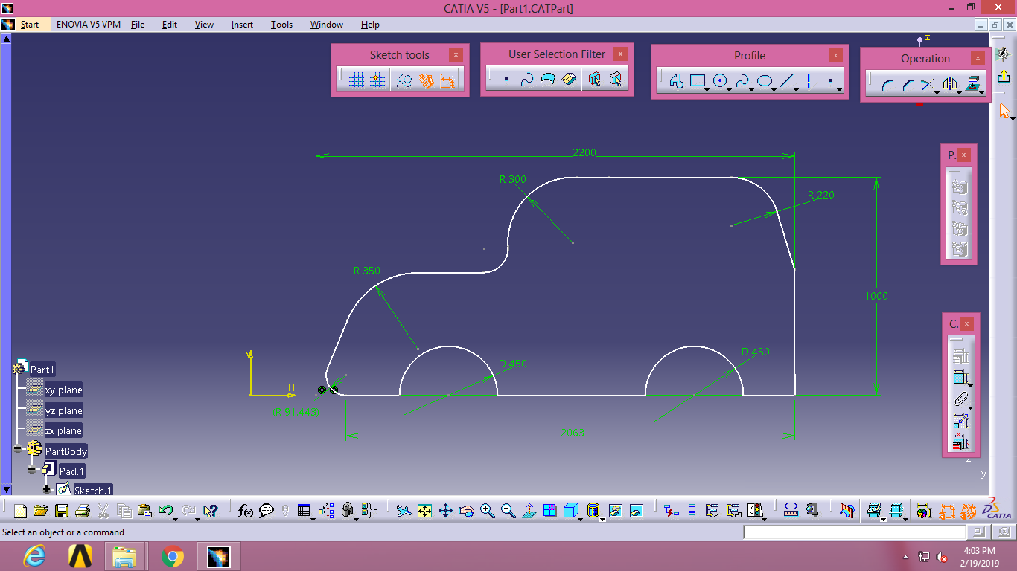**Figure 25: Car sketch in Catia**

Then exit the sketch view, after this PAD the car sketch with Mirror extension as width of car 1.5m (750mm mirror length).The final formed car model is as follows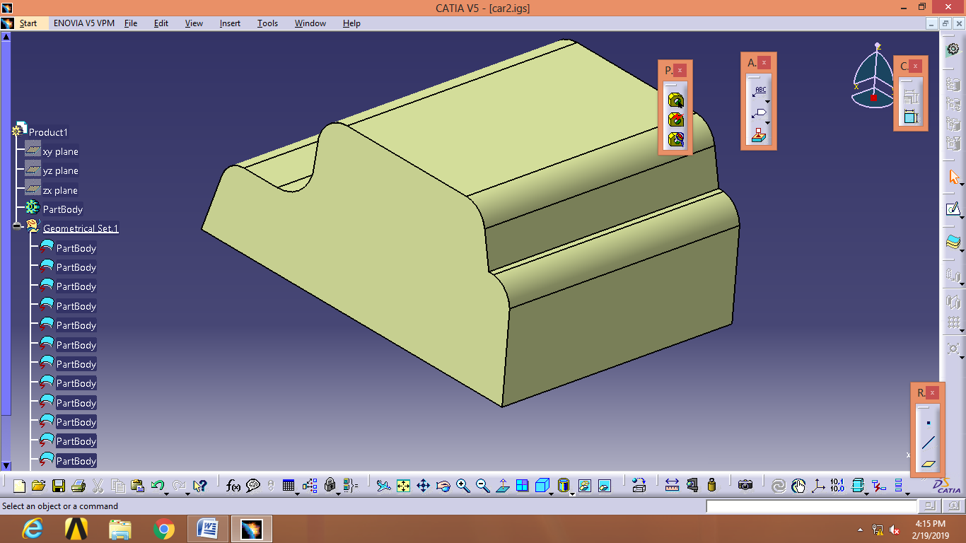**Figure 26: final car model in 3D**

Similarly generate the car 3D models Car Vs. Car in frontal impact and side impact sketches

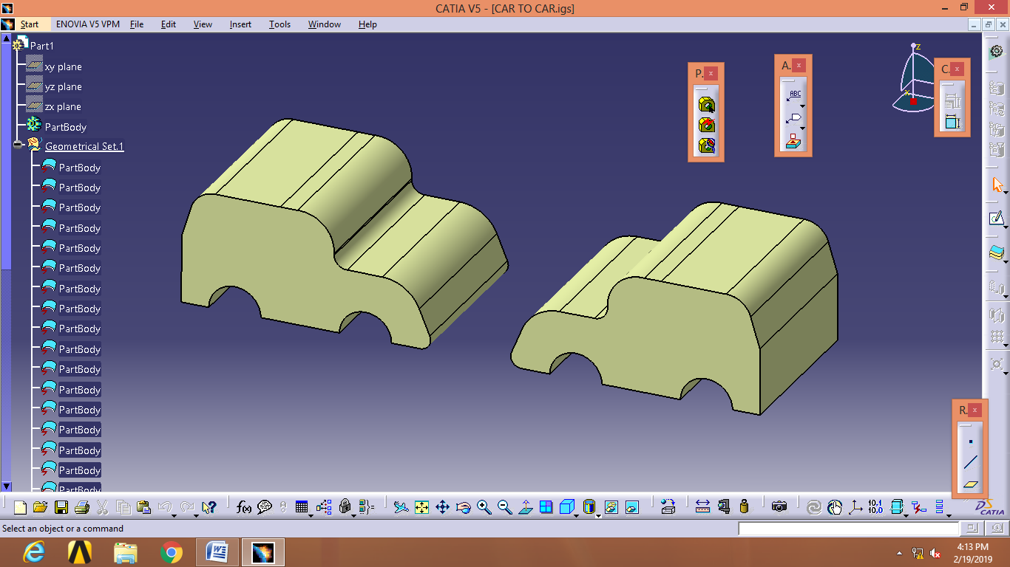

**Figure 27 : Car Vs. Car frontal impact**

By Solid Mirroring the car 3D model we can Generate the above model.

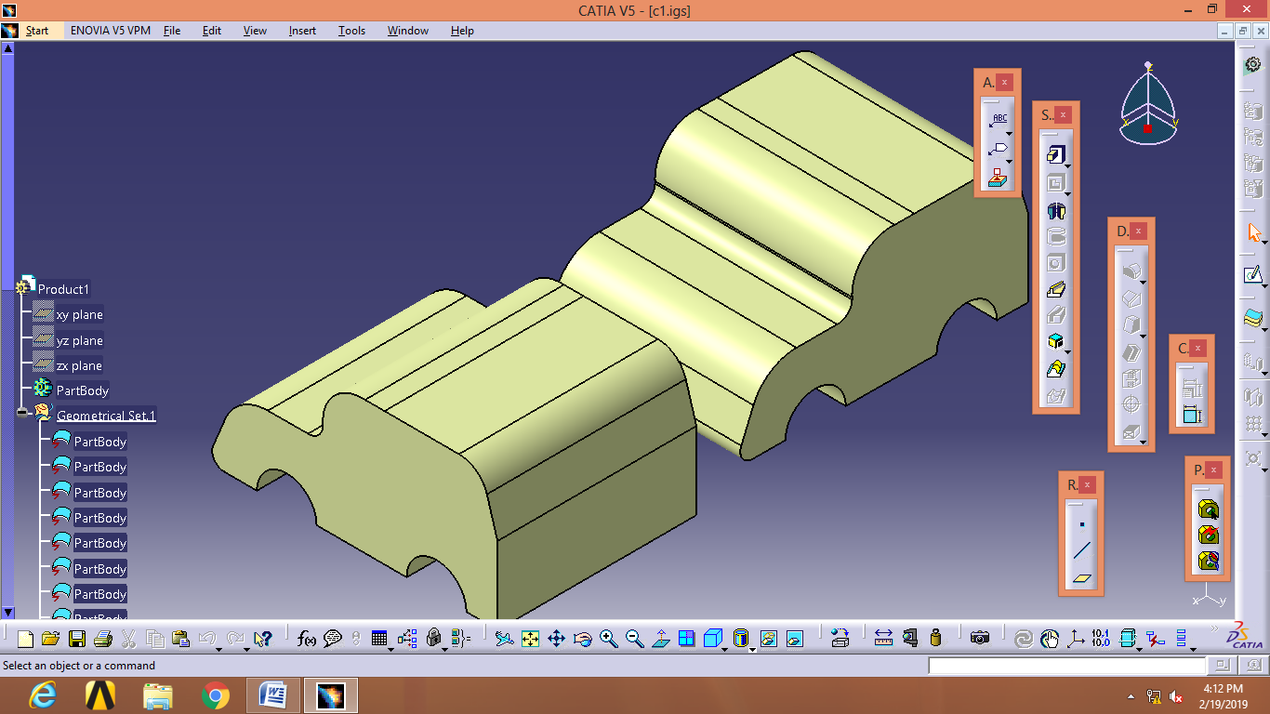

**Figure 28 : Car Vs. Car Side impact**

By Solid Mirroring the car 3D model and then 3D Rotation we can Generate the above model.

## **6.2 CAR MATERIALS:** In general car body materials are different for every cars manufacturing company,some of the car materials are as follows,

For 🡪 AUDI and TOYOTA – carbon fiber reinforced polymer,Aluminium

🡪Ferrari – Aluminium ,Structural Steel, Kevlar, Carbon fiber

🡪 BMW – Aluminium, HSS, Magnesium Alloy.

Now in our project we are taken Materials are Especially two ,They are Aluminium Alloy, Magnesium Alloys As car body materials and Structural Steel as Obstacle.

The properties of materials are as follows,

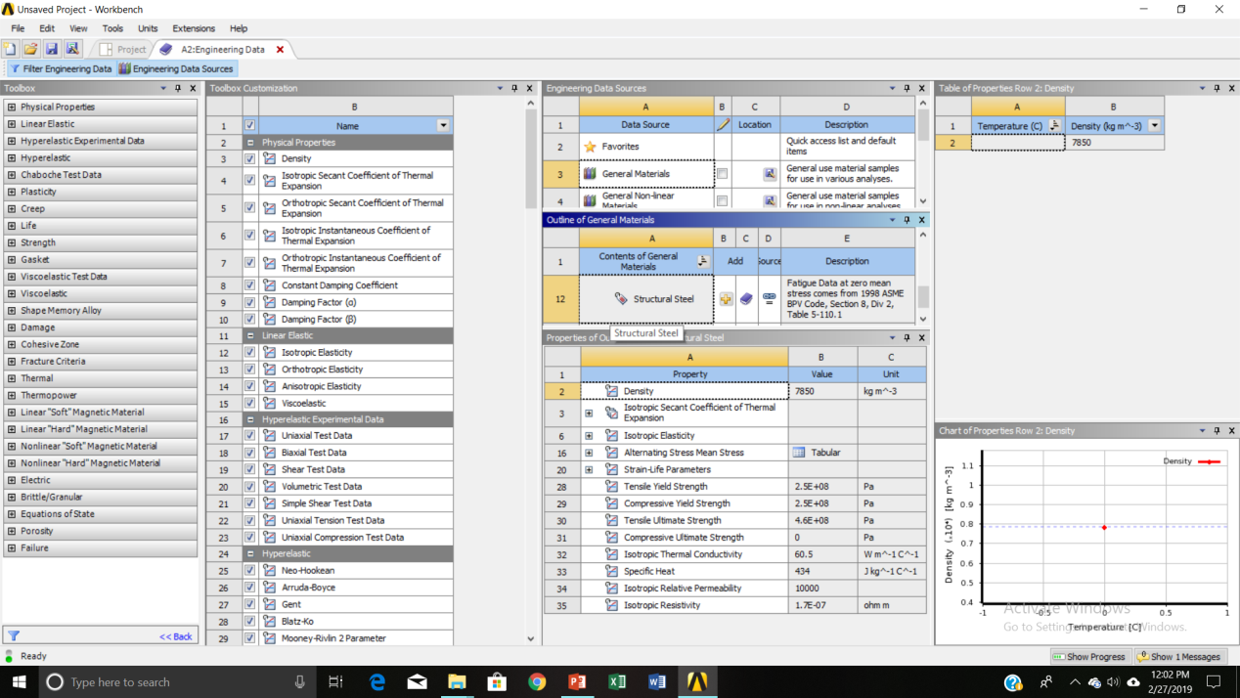 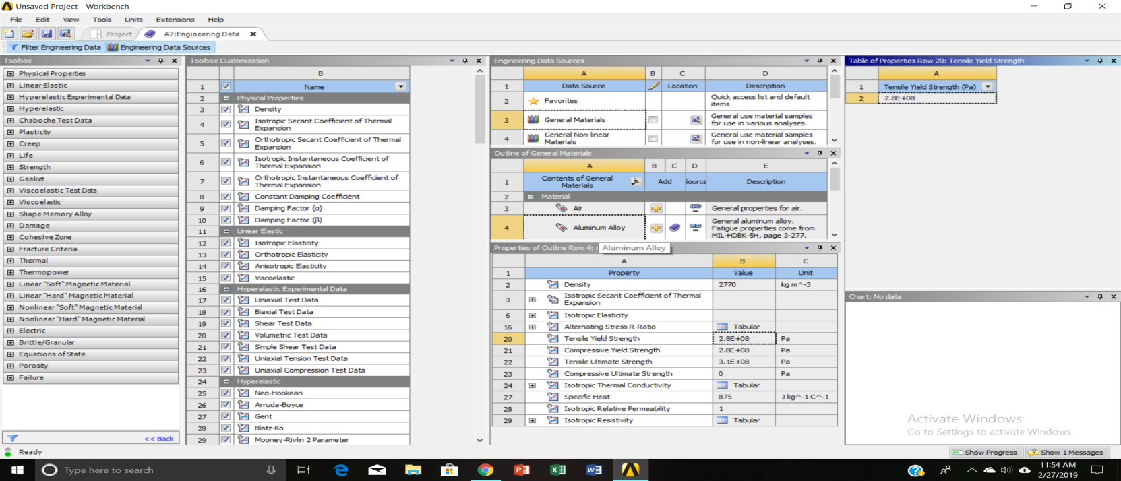

*Structural Steel Properties Aluminium Alloy properties*

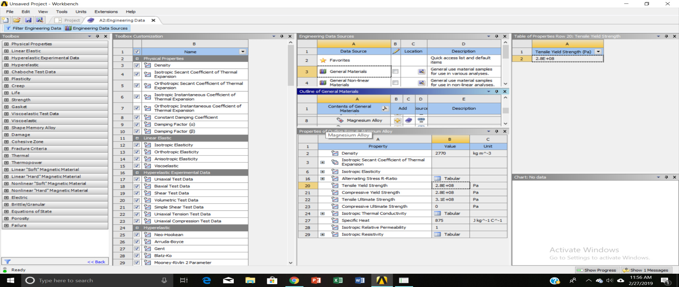

*Magnesium Alloy properties*

The above figure represents material properties which are assigned in ANSYS 14.5

## **6.3 CRASH ANALYSIS DONE ON A CAR WITH FOLLOWING PARAMETERS AND CONSIDERATIONS**

In this thesis what we are done is crash analysis of a four-wheel vehicle as car with some considerations are velocity variations with material selection, in the sense

* Velocities of car at 35m/s,45m/s,55m/s and 60m/s we are taken at the same time car materials such as structural steel, Aluminium Alloy and Magnesium Alloys.
* Finally, what we are taken are the following combinations for crash analysis.

#### 6.2.1 Frontal impact Car crash against an Obstacle(wall)

#### 6.2.2 Frontal impact Car crash against another Car

#### 6.2.3 Side impact Car crash against another car

Velocity combinations with materials are as follows,

### ***6.2.1 Frontal impact Car crash against an Obstacle(wall)***

Car Material as Aluminium Alloy, Obstacle as Structural Steel

* Velocity of car at 35m/s (35+Al+SS)
* Velocity of car at 45m/s (45+Al+SS)
* Velocity of car at 55m/s (55+Al+SS)

1. Car Material as Magnesium Alloy, Obstacle as Structural Steel

* Velocity of car at 35m/s (35+Mg+SS)
* Velocity of car at 45m/s (45+Mg+SS)
* Velocity of car at 55m/s (55+Mg+SS)

### ***6.2.2 Frontal impact Car crash against another Car***

1. Velocity of car at 45m/s, both the car materials are Aluminium Alloy
2. Velocity of car at 45m/s, both the car materials are Magnesium Alloy

### ***6.2.3 Side impact Car crash against another car***

1. Both car materials are Aluminium Alloy

* Velocity of car at 55m/s (55+Al+Al)
* Velocity of car at 60m/s (60+Al+Al)

1. Both car materials are Magnesium Alloy

* Velocity of car at 55m/s (55+Mg+Mg)
* Velocity of car at 60m/s (60+Mg+Mg)

For below 35m/s velocity the Total Deformations and stresses are minor, so that below 35m/s velocities combinations we are not taken.

Then crash analysis is done in ANSYS EXPLICIT DYNAMICS module in ANSYS WORKBENCH 14.2.

The procedure is as follows, and the results are followed by next.

**In brackets notations we are assigned it is shown in ANSYS results images.**

## **6.3 CAR CRASH ANALYSIS IN ANSYS WORKBENCH 14.5 IN THE MODULE OF ANSYS EXPLICT DYNAMICS**

### ***Procedure:***

Open ANSYS workbench 14.2 software 🡪 Double click on Explicit Dynamics 🡪then apply the following set of entities,

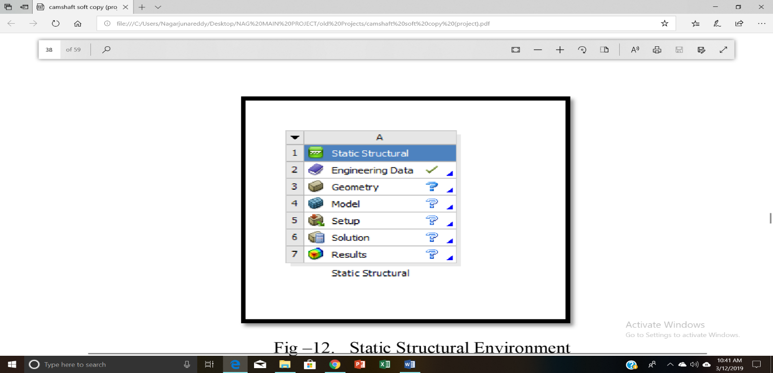

**Figure 29 : Explicit dynamics Environment**

**Engineering data**

Double click on engineering data 🡪 click on engineering data sources 🡪 select general materials🡪 Add Aluminium Alloy 🡪 update project 🡪 Return to project.

**Geometry**

Right click on Geometry and then import the IGS file of car drawn in CATIA 🡪 then double click on geometry🡪 then draw the obstacle 🡪 return to project.

**Mesh type: Quad/Triangular**

**Model**

Double click on model 🡪 select geometry 🡪 Apply materials to each bodies obstacle as structural steel and car body as Aluminium Alloy

🡪Mesh generation 🡪 click on mesh 🡪 sizing 🡪 fine 🡪 generate mesh.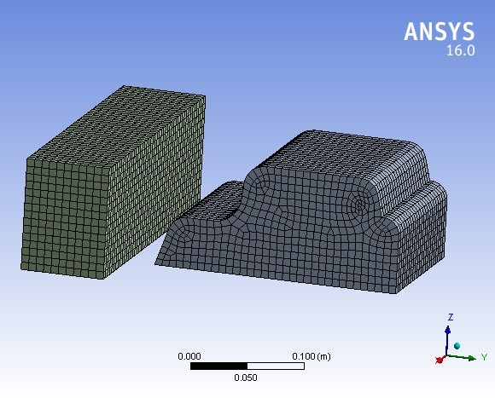

**Figure 30 : Meshed Model car vs. obstacle**

**Explicit Dynamics**.

Right click on Explicit Dynamics 🡪 Insert 🡪 Velocity 🡪 select direction of velocity(x,y,z with respect to object🡪 Apply on object (total body).

Analysis settings 🡪set the end time as 0.01seconds.

**Solution Generation**

*Right click on solution 🡪 insert 🡪 Deformation 🡪 Total.

*Right click on solution 🡪 insert 🡪 Stress 🡪 Equivalent (Von-mises).

*Right click on solution 🡪 insert 🡪 Strain 🡪 Equivalent (Von-mises).

Finally, right click on solution 🡪 click on solve to generate all results.

Similarly, the other meshed models are as follows,

**Mesh type: Quad/Triangular**

**The Results are followed by meshed models.**

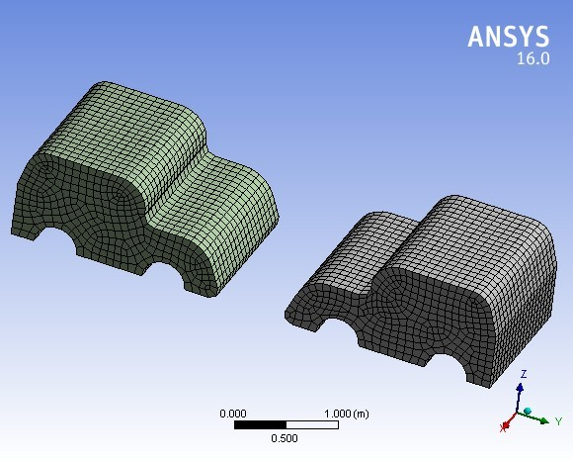:

**Figure 31 : Meshed Model car vs. car frontal impact crash**

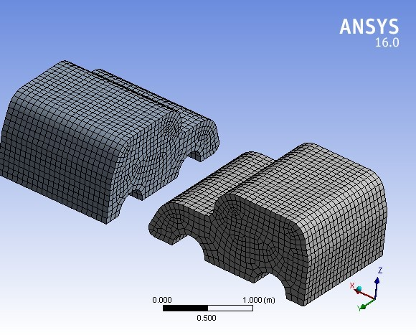

**Figure 32 : Meshed Model car vs. car side impact crash**

**A SMALL NOTATION WE ARE ASSIGNED,**

Such as 35+Al+SS+Deformation, like that,

Here 🡪35 means velocity of car

🡪 AL, Mg are Aluminium and Magnesium Alloys materials of car

🡪 SS means Structural Steel as material assigned to Obstacle.

The results are as follows

Followed by all results are represented in tabular forms and then comparative graphs.

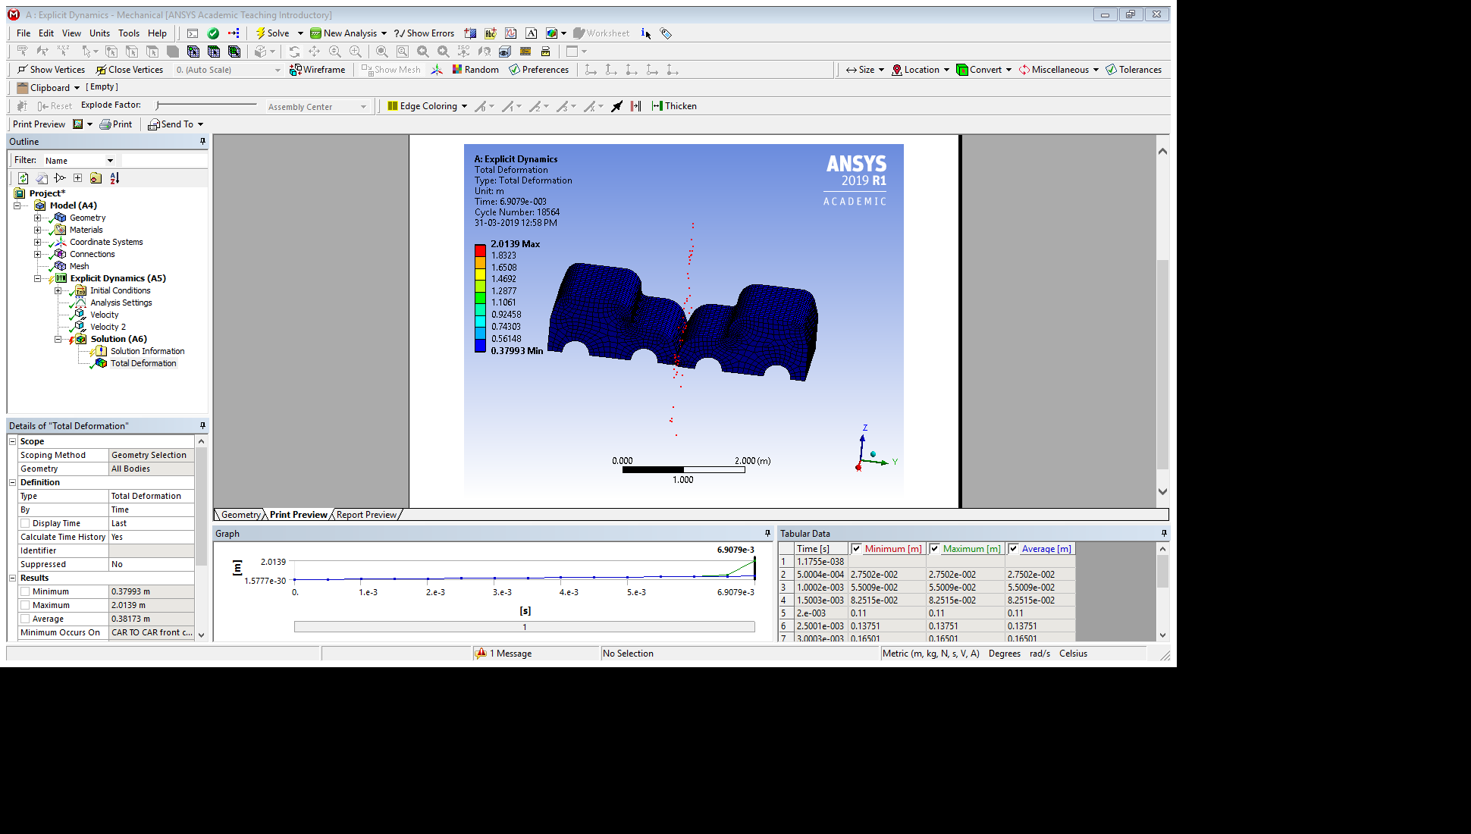

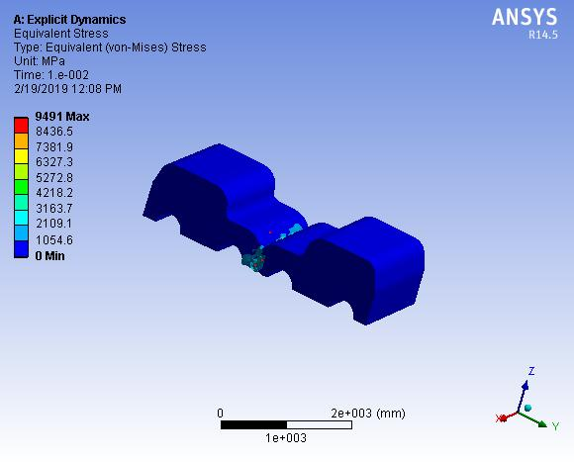**Figure 33 : 45+AL+AL+F+DEFORAMTION**

**Figure 34 : 45+AL+AL+F+STRESS**

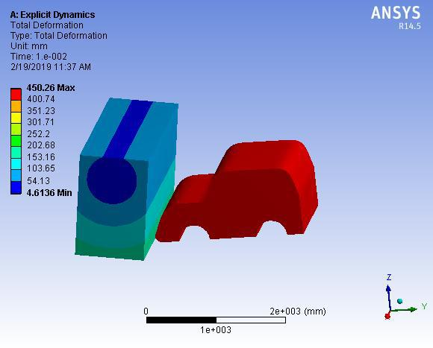The following all results are tabulated in table form and respective comparative graphs.

**Figure 35 : 45+AL+SS+F+DEFORMATION**

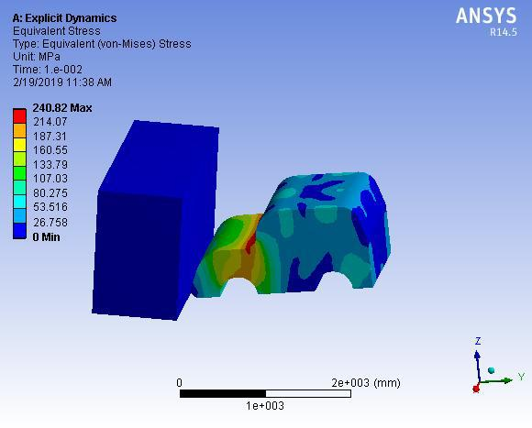

**Figure 36 : 45+AL+SS+F+STRESS**

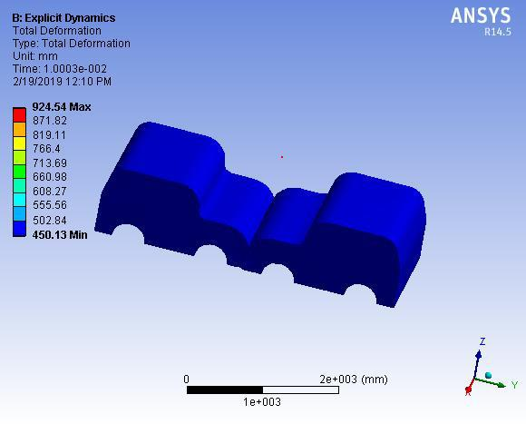

**Figure 37 : 45+MG+MG+F+DEFORMATION**

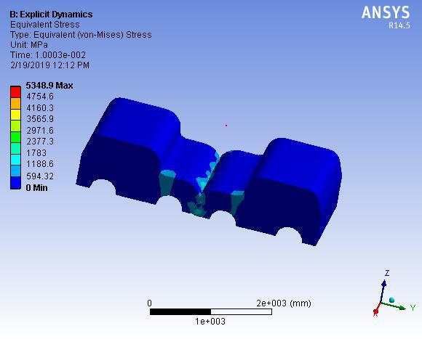

**Figure 38 : 45+MG+MG+F+STRESS**

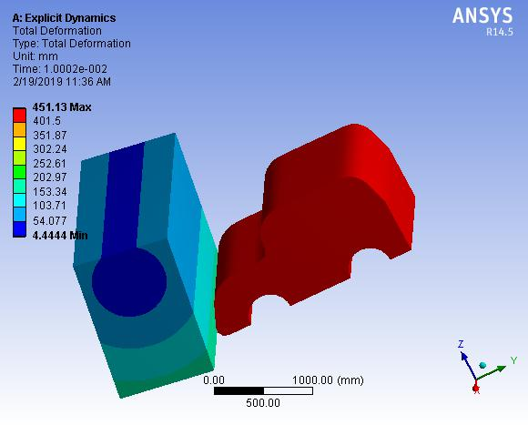

**Figure 39 : 45+MG+SS+F+DEFORMATION**

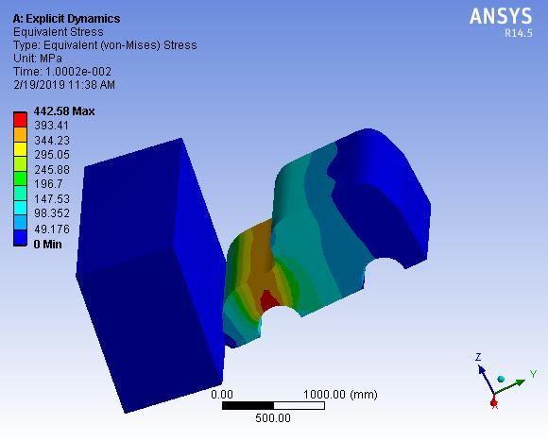

**Figure 40 : 45+MG+SS+F+STRESS**

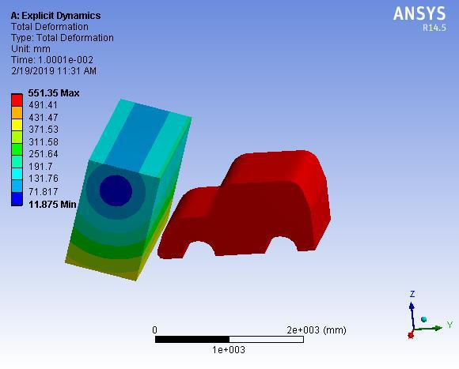

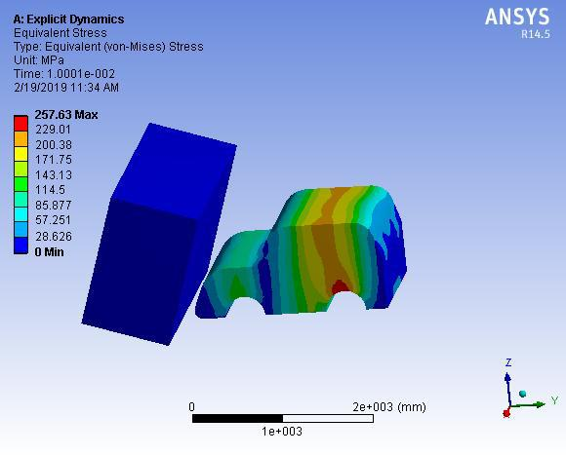**Figure 41 : 55+AL+SS+F+DEFORMATION**

**Figure 42: 55+AL+SS+F+STRESS**

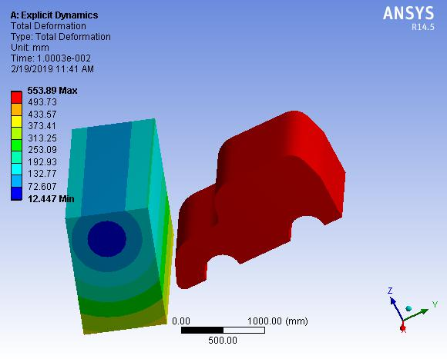

**Figure 43 : 55+MG+SS+F+DEFORMATION**

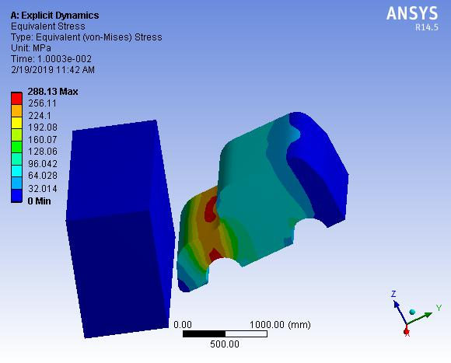

**Figure 44 : 55+MG+SS+F+STRESS**

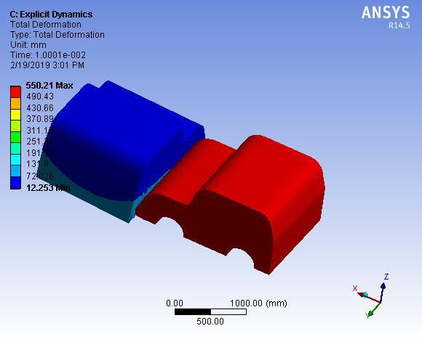

**Figure 45 : 55+AL+AL+S+DEFORMATION**

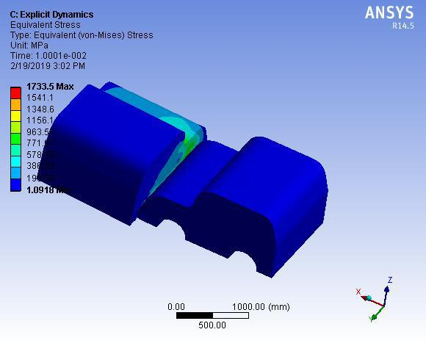

**Figure 46 : 55+AL+AL+S+STRESS**

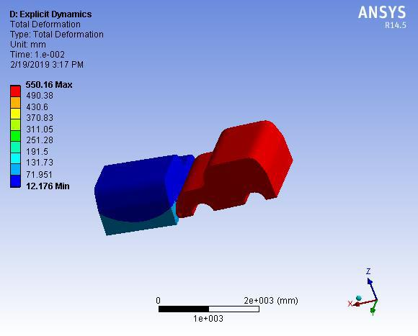

**Figure 47 : 55+MG+MG+S+DEFORMATION**

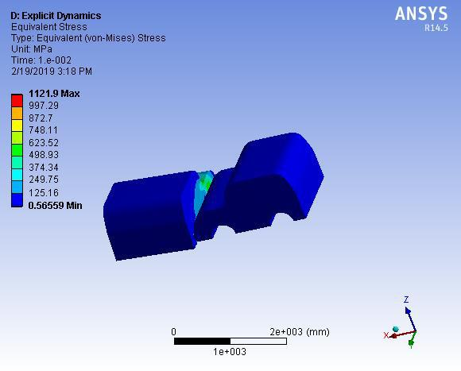

**Figure 48 : 55+MG+MG+S+STRESS**

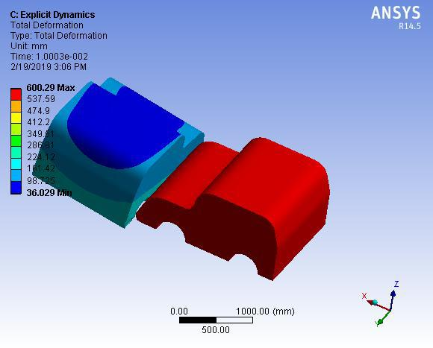

**Figure 49 : 60+AL+AL+S+DEFORMATION**

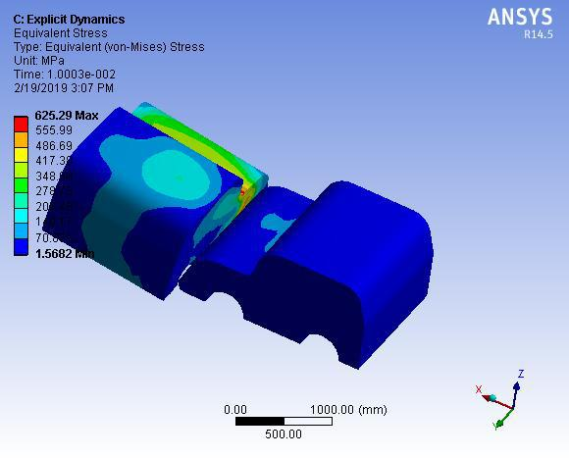

**Figure 50 : 60+AL+AL+S+STRESS**

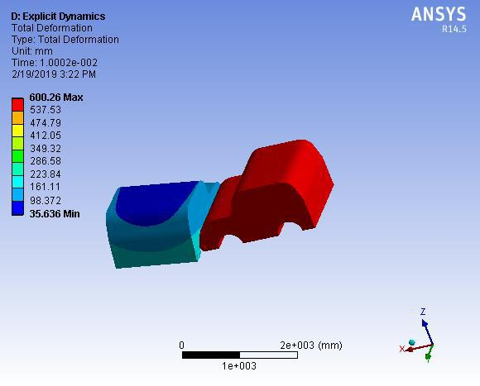

**Figure 51 : 60+MG+MG+S+DEFORMATION**

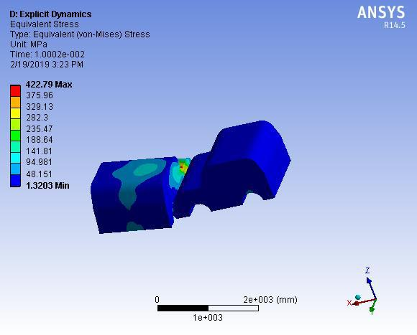

**Figure 52 : 60+MG+MG+S+STRESS**

# **CHAPTER – 7**

# **RESULT TABLES AND GRAPHS**

**FRONTAL IMPACT, CAR VS. OBSTACLE  
Car Material-Aluminium Alloy, Obstacle-Structural Steel**

|  |  |  |  |  |
| --- | --- | --- | --- | --- |
| **S.NO** | **VELOCITY** (**m/s)** | **TOTAL DEFORMATION (mm)** | **STRAIN** | **STRESS**  **(N/mm2)** |
| 1 | 35 | 350.02 | 0.0016977 | 117.68 |
| 2 | 45 | 450.26 | 0.0033969 | 240.82 |
| 3 | 55 | 551.35 | 0.0036422 | 257.63 |

**Table 1 : Car Frontal Impact with Obstacle (Car Material as Al Alloy)**

**FRONTAL IMPACT, CAR VS. OBSTACLE  
Car Material-Magnesium Alloy, Obstacle-Structural Steel**

|  |  |  |  |  |
| --- | --- | --- | --- | --- |
| **S.NO** | **VELOCITY** (**m/s)** | **TOTAL DEFORMATION (mm)** | **STRAIN** | **STRESS**  **(N/mm2)** |
| 1 | 35 | 350.03 | 0.0018185 | 80.148 |
| 2 | 45 | 451.1 | 0.0098514 | 442.58 |
| 3 | 55 | 553.89 | 0.0064069 | 288.13 |

**Table 2 : Car Frontal Impact with Obstacle (Car Material as Mg Alloy)**

**FRONTAL IMPACT, CAR VS. CAR**

|  |  |  |  |  |  |
| --- | --- | --- | --- | --- | --- |
| **S.NO** | **VELOCITY**  (**m/s)** | **MATERIAL** | **TOTAL DEFORMATION**  **(mm)** | **STRAIN** | **STRESS**  **(N/mm2)** |
| 1 | 45 | Aluminium Alloy | 654.84 | 0.18102 | 9491 |
| 2 | 45 | Magnesium Alloy | 924.54 | 0.12171 | 5348.9 |

**Table 3 : Car Frontal Impact with Car**

**SIDE IMPACT, CAR VS. CAR  
Car Materials-Aluminium Alloy**

|  |  |  |  |  |
| --- | --- | --- | --- | --- |
| **S.NO** | **VELOCITY** (**m/s)** | **TOTAL DEFORMATION (mm)** | **STRAIN** | **STRESS**  **(N/mm2)** |
| 1 | 55 | 550.21 | 0.029581 | 1733.5 |
| 2 | 60 | 600.29 | 0.0090137 | 625.29 |

**Table 4 : Car Side Impact with Car (Car Material as Al Alloy)**

**SIDE IMPACT, CAR VS. CAR  
Car Materials-Magnesium Alloy**

|  |  |  |  |  |
| --- | --- | --- | --- | --- |
| **S.NO** | **VELOCITY** (**m/s)** | **TOTAL DEFORMATION (mm)** | **STRAIN** | **STRESS**  **(N/mm2)** |
| 1 | 55 | 550.16 | 0.030022 | 1121.9 |
| 2 | 60 | 600.26 | 0.0095194 | 422.79 |

**Table 5: Car Side Impact with Car (Car Material as Mg Alloy)**

**FRONTAL IMPACT, CAR VS. OBSTACLE  
Car Materials - Aluminium Alloy and Magnesium Alloy, obstacle-Structural Steel**

**Graph 1 : Total Deformation with respect to different velocities (Car Vs. Obstacle)**

**Graph 2 : Strain with respect to different velocities (Car Vs. Obstacle)**

**Graph 3 : Stress with respect to different velocities (Car Vs. Obstacle)**

**FRONTAL IMPACT, CAR VS. CAR**

**Bar Graph 1 : Total Deformation with respect to materials(Car Vs. Car)**

**Bar Graph 2 : Stress with respect to materials(Car Vs. Car)**

**Bar Graph 3 : Strain with respect to materials(Car Vs. Car)**

**SIDE IMPACT, CAR VS. CAR**

**Graph 4 : Total Deformation with respect to different velocities (Car Vs. Car)**

**Graph 5 : Strain with respect to different velocities (Car Vs. Car)**

**Graph 6 : Stress with respect to different velocities (Car Vs. Car)**

# **CHAPTER – 8**

# **CONCLUSION**

It was seen that at low velocity majority of the impact force was absorbed by the front part of the car with slight deformation. But at high velocity, impact resulted in permanent deformation of the car model. The extent of plastic deformation of the car increased with increase in velocity with front part of the car absorbing the major part of the impact energy, Bumper, bonnet, A pillar and wind shield were the major parts to undergo plastic deformation.

Coming to material variations we are observed are

**I. Deformation**

Deformations in all cases almost similar for both the materials (Aluminium and Magnesium Alloys. (Graphs 1 and 4)

**II. Stress**

Stress values at Car crash against obstacle, for Magnesium Alloy car body the stress values are more and in Car crash against A another Car the stress values for Aluminium Alloy car body are more. (from Graph 3)

**III. Strain**

Strain values for Aluminium Alloy is more on comparing with Magnesium Alloy Car Body Materials. (from bar graph 3).

# Finally, Aluminium Alloy car body material is much better than Magnesium Alloy car body material.

# **REFERENCES**

[1] T. Ambati, Srinath, P. Veeraraju “simulation of vehicular frontal crash test” international journal of applied research in mechanical vol-2 (2012)

[2] Byeong S.K, K. Park, Youn-Min Song “finite element frontal crash analysis of nev- vehicles platform with upper and sub frame body journal of dept. of automotive engineering hoseo university (2013)

[3] Erika Fechova, Jozef Kmec, Alena Vagaska Drazan Kozak “material properties and safety of car at crash test”, journal of international conference on manufacturing engineering and materials, science direct (2016)

[4] Saeed Barbat, Xiaowei Li, Priya Prasad “vehicle to vehicle front to side crash analysis using a CAE based methodology “journal of passive safety research and advanced engineering (2004)

[5] Jadav Chetan, Panchal Khushbu, Moulvi Nauman “the fatigue analysis of a vehicle suspension system –A review article” international journal of advanced computer research (2012)

[6] Hariharan Sankar Subramanian Sudipto Mukherjee,” optimization of vehicle front for safety of pedestrians” Indian institute of technology, Delhi, India, 2014.

[7] C. Sadhasivam & S. Jayalakshmi,” simulation of car body by development of static and dynamic analysis” department of mechanical engineering, pet engineering college, Tirunelveli, Tamilnadu, India 2011.

[8] Mandeep Kumar Vandanapu1, Ratnakar Pandu,” design optimization of passenger car front bumper” international journal of science and research (IJSR) 2015.

[9} G D Lohith Kumar, H S Manjunath, N Shashikanth, Venkatesh Reddy are done crash analysis of a four-wheel vehicle with different velocities. (2018 August).